**Smart Water Tank Switch**

**Features:**

* Motor switch will On/Off automatically.
* User can set tank height
* User can set when to turn on switch automatically.
* User can set when to turn off switch automatically.
* User can see water percentage at device display
* Also user can turn on/off switch manually.
* User can set a time like alarm. Everyday at that time motor will be turned on & turned off at turn-off percentage automatically.

**Urgent Features:**

* If suddenly device not work or anyone want to turn On motor at any cost, then motor can be turned On using manual features.
* If anyone want to turn Off motor at any cost, then motor can be turned Off using device switch.

**Component:**

* Arduino Uno x1
* WATERPROOF Ultrasonic Sensor x1 (Max distance: 4.5 meter)
* LCD Display x1
* Keypad x1
* RTC Module x1
* Relay (12V 30A Power Relays) x2
* Red & Green LED x5 &5
* Battery/Adaptor (9V) x1

**Real Life Application:**

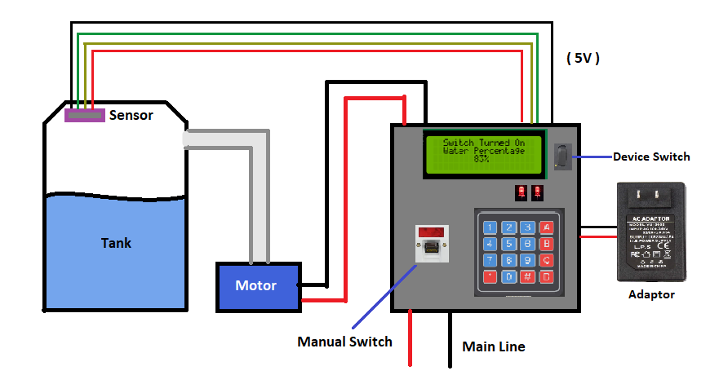

**Example Simulation:**

https://wokwi.com/projects/369934930201693185